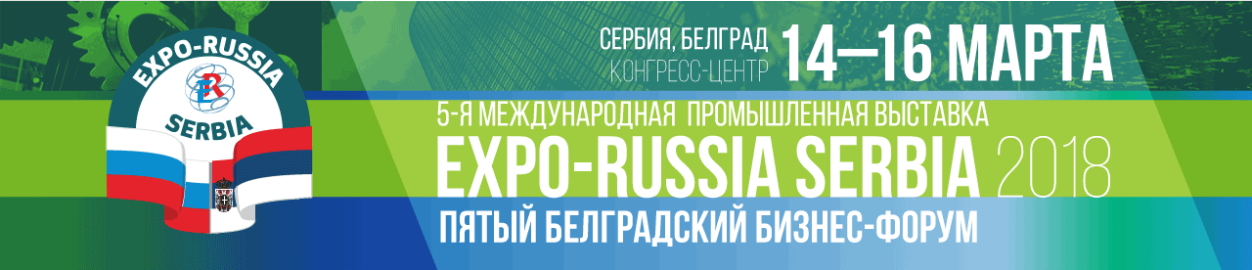
BUSINESS PROGRAM
OF THE 5TH INTERNATIONAL INDUSTRIAL EXHIBITION
EXPO-RUSSIA SERBIA 2018
OF THE 5TH BELGRADE BUSINESS FORUM

OF THE BUSINESS MISSION OF RUSSIAN ENTERPRISES TO THE REPUBLIC OF SERBIA
March 14-16, 2018
Belgrade, Metropol Palace conference center
20 February
14:00 Press-conference on opening of the 5th Anniversary International Industrial Exhibition EXPO-RUSSIA SERBIA 2018, Metropol Palace Hotel
March 14, Wednesday

12:00 – 12:30 EXPO-RUSSIA SERBIA 2018 official opening ceremony
Exhibition area tour for officials and honorary guests
13:30 – 16:00 Round table of the Ministry of Economic Development of the Russian Federation “Prospects for cooperation in the field of innovation, including in small and medium-sized enterprises” with participation of Deputy Minister of Economic Development of the Russian Federation A. V. Gruzdev jointly with the Ministry of Innovations of the Republic of Serbia, Chamber of Commerce and Industry of Serbia.
Presentation of companies and regions Lavender Room
16:40 – 18:00 Round table jointly with the Ministry of Agriculture, Forestry and Water Management
Lavender Room.
March 15, Thursday
10:00 – 18:00 Business Contacts Exchange in a B2B meeting format, Expo hall
11:00 – 13:00 Round table jointly with the Ministry of Health of the Republic of Serbia “Prospects of joint studies in the field of medicine, sharing of best practices between Russian and Serbian clinics, joint production of medicines and medical equipment”, Lavender Room
14:00 – 16:00 Round table jointly with the Ministry of Mining and Energy of the Republic of Serbia “Pressing issues of cooperation of Russia and Serbia in the field of traditional and alternative energy, development of energy-saving technologies”, Lavender Room
18:00 Floristic show for all! by ARAIK GALSTYAN, hall “Lavender”
March 16, Friday
10:00 – 12:00 Round table jointly with the Ministry of Trade, Tourism and Telecommunications of the Republic of Serbia “Russia-Balkans potential for tourism”, Lavender Room.
12:00 – 14:00 Round table jointly with the Ministry of Education and Science of the Russian Federation and the Ministry of Education, Science and Technological Development of the Republic of Serbia “ON THE ISSUES IN SCIENTIFIC AND TECHNICAL COOPERATION AND TECHNOLOGY TRANSFER”, Lavender Room.

14:00 – 16:00 Round table jointly with the Ministry of Construction, Transport and Infrastructure of the Republic of Serbia “On ways to improve the Balkans transportation system and cooperation in the field of construction in the course of development of the Russian-Serbian trade and economic relations”, Lavender Room.
16:30 Official Diploma awarding ceremony. Lobby of the exhibition hall.

ORGANIZING COMMITTEE: Zarubezh-Expo, JSC
Tel.: +7 (495) 721-32-36, 637-50-79; +7 (499) 766-99-17; +381 69 177 55 70
www.zarubezhexpo.ru, info@zarubezhexpo.ru, petroleus@yandex.ru
 +381 11/33 00 900, www.pks.rs

